5E CondorKids Middle School Unit
By USFWS Hopper Mountain National Wildlife Refuge Complex, Teachers from Fillmore Unified School District and Santa Paula Unified School District: Laurie Merrill and Cynthia Martin, and support from Oxnard School District Science Instructional Specialist Sarah Raskin (template adapted from Annie Ransom)
Standards
MS-LS2-3. Develop a model to describe the cycling of matter and flow of energy among living and nonliving parts of an ecosystem. [Clarification Statement: Emphasis is on describing the conservation of matter and flow of energy into and out of various ecosystems, and on defining the boundaries of the system.] [Assessment Boundary: Assessment does not include the use of chemical reactions to describe the processes.]
MS-LS2-4. Construct an argument supported by empirical evidence that changes to physical or biological components of an ecosystem affect populations. [Clarification Statement: Emphasis is on recognizing patterns in data and making warranted inferences about changes in populations, and on evaluating empirical evidence supporting arguments about changes to ecosystems.]

Partially addressed:

MS-LS2-5. Evaluate competing design solutions for maintaining biodiversity and ecosystem services.* [Clarification Statement: Examples of ecosystem services could include water purification, nutrient recycling, and prevention of soil erosion. Examples of design solution constraints could include scientific, economic, and social considerations.]
MS-LS2-1. Analyze and interpret data to provide evidence for the effects of resource availability on organisms and populations of organisms in an ecosystem. [Clarification Statement: Emphasis is on cause and effect relationships between resources and growth of individual organisms and the numbers of organisms in ecosystems during periods of abundant and scarce resources.]

SEP: Asking Questions, Developing and Using Models, Analyzing and Interpreting Data, Using Mathematics and Computational Thinking, Constructing Explanations, Engaging in Argument from Evidence, and Obtaining, Evaluating, and Communicating Information

Environmental Principles & Concepts
Principle 1 - People Depend on Natural Systems  Principle 2 - People Influence Natural Systems  Principle 3 - Natural Systems Change in Ways that People Benefit From & Can Influence | Principle 4 - There are no Permanent or Impermeable Boundaries that Prevent Matter from Flowing Between Systems  Principle 5 - Decisions Affecting Resources and Natural Systems are Complex and Involve Many Factors
EP&Cs Flyer EP&Cs Infographic

Essential Question
What role does the California condor play in the California ecosystem, and how do changes in the ecosystem impact condors over time?

Engage – Anchor Phenomenon and Preliminary Model
1 Day: 45 minutes
Lesson 1 – Intro and Preliminary Model

- Engage: Condor Feeding Frenzy Videos Condors feeding on deer carcass
- Optional videos: Condor Eats Deer Heart, Condors Eating a Pig, Condors Supplemental Feeding Central California, Condor vs Eagle
- Create a preliminary model of how the condor interacts with its environment
- Gallery Walk
- Revise Models

Explore/Explain #1 – GIS Tutorial and Week 1 GIS Lab
2 days: 60/45 minutes
Lesson 2: GIS Tutorial and Activity 1
Day 1:
- Warm-Up
- GIS Activity Tutorial

Day 2:
- Warm-Up
- Intro and assign groups a condor to monitor
- GIS Data Sheet – Week 1 (Habitat)
- Class Discussion

Explore/ Explain #2 – Week 2 GIS Lab & Hopper Mountain Food Web
2 days: 45/50 minutes
Lesson Plan 3 – GIS Activity 2
- Warm-Up
- Re-watch Anchor Video
- GIS Data Sheet – Week 2

Lesson Plan 4 – Developing the Hopper Mountain Food Web Model
- Warm-Up
- Gather Information/ Research
- Building a Hopper Mountain Food Web Model
- Class Discussion
- Revising the Food Web Model
- Revise Preliminary Model

Explore/ Explain #3 – Week 3 GIS Lab and Scavenger Success
2 Days: 45/40 minutes
Lesson Plan 5 – GIS Week 3
- Warm-Up
- Class Discussion
- GIS Activity Week 3

Lesson Plan 6 – Gnarly Nutrients
- Deer Decomposition Video
- Close Reading of article
- Re-watch Anchor Video and Discussion
- Revise Model
- Reflection
- Optional Homework

Explore/ Explain #4 –GIS Lab Week 4 and Graphing Human Impacts
2 Days: 45/45 minutes
Lesson Plan 7 – GIS Week 4 Human-CACO Connection
- Warm-Up
- GIS Activity Week 4
- Reflection

Lesson 8: Rise and Fall
- Warm-Up
- Jigsaw Activity
- Making Graphs
- Sharing the Data
Lesson 9: Claim-Evidence-Reasoning

Explore/ Explain #5 – The Condor’s Shadow and Do the Math!
1 Day: 60 minutes
Lesson 10: The Condor’s Shadow and Do the Math!
- Watch Condor’s Shadow video
- Do the Math Activity

Lesson 11: Question Formulation Technique
- Warm-Up
- Question Formulation Technique *Guest speaker is not guaranteed. Video or written question responses can be substituted.

Explore/ Explain #6 – Expert Answers and Microtrash Madness
1 Day: 45 minutes
Lesson 12: Microtrash Madness!!

Elaborate – Public Service Announcements
2 Days: 30/30 minutes
Lesson 13: Save the Birds
- Create a PSA/ Billboard/ Sign/ Video/ Poster encouraging people how to prevent microtrash or lead from entering the condor’s environment.
- Share with FWS Park Ranger for possible showcase on Facebook or Websites
Funny video example Serious video example Kid made signage

Evaluate – Claims, Evidence, and Reasoning
1 Day: 30-45 minutes
Lesson 14: C-E-R
- CER
- Rubric

Estimated time to complete: lesson plans 30-60 minutes; 15 lesson days (50-minute periods)

Table of Contents:
Engage: Anchoring Phenomena and Preliminary Model
Explore/Explain 1: GIS Tutorial and GIS Lab Week 1: Habitat
Explore 2: GIS Lab Week 2: Behavior
Explain 2: Developing the Hopper Mountain Food Web Model
Explore 3: GIS Lab Week 3: Ecosystem Roles
Explain 3: Scavenger Success
Explore 4: GIS Lab Week 4: Human Impacts
Explain 4: Population and Mortality
Explore 5: The Condor’s Shadow – Video
Explain 5: Do the Math!
Explore 6: Question Formulation Techniques
Explain 6: Expert Answers (Guest Speaker)
Explore7: Microtrash Madness
Explain 7: Final Model Revision
Elaborate: California condor PSAs
Evaluate: Claims, Evidence, and Reasoning

*Most lessons include a Warm Up: Condor chick nest cam clips or CondorKids Professionals
- This is meant to engage, and connect students with condors as more than just scavengers. The chicks are “cute” and the parents provide a lot of love and care. There is not much attention given to the reproductive and nesting lives in this Unit.
- Professionals show various examples of the different careers people have for the recovery of California condors, including volunteering.

Lesson Plan 1: Introduction and Preliminary Model
Unit Question: What role does the California condor play in the California ecosystem, and how do changes in the ecosystem impact condors over time?

Science and Engineering Practices:
- Developing and Using Models
- Obtaining Evaluating and Communicating Information

Lesson 1: (one class period)
1. Engage: Show the Condor Feeding Frenzy Video (1)
- Optional videos: Big Sur Feeding Frenzy Big Sur Feeding Frenzy
- Have students watch the video once.
- Show the video a second time. Have the students share out what they notice or see in the video. Have the students share out what it makes them think about or reminds them of. (This could be done as a See – Think – Wonder: Directions - Worksheet)
- Questions - ask the students to write questions that they have on Post-Its (one question per post-it). Then have students share their questions with a partner or small group. Students should generate more questions together and write the questions on Post-Its (one question per Post-It).
- Have students share their questions with the class. Teacher should save the questions on a piece of poster paper called the “Question Board.” – Students will return to these questions throughout the unit and add to the Question Board.

2. Create a Preliminary Model
- Example Model
  - Ask the students how do you interact with your school environment? (Example answers: with other kids, teacher, food, bathroom, benches, desks, water fountain).
  - As a class, draw an example model on the whiteboard of a student interacting with their school environment. Include arrows, pictures (symbols), and written explanations.

- Create a preliminary model of how the condor interacts with its environment
In small groups, students will create a model of how they think the California condor interacts with its environment in California.
- Model should include arrows, words/sentences, drawings, etc.
- Students will share their models with their group.
- Model should have similarities to the example model (biological, social, travel)
*Teacher note: this is a preliminary model, so students do not need to have any background knowledge about the condor. You can use this to evaluate what students know.

3. Gallery Walk
- Have the students do a gallery walk (or you could do class presentations) of the preliminary models.

4. Revise models
- After the Gallery walk (or presentations), students can work in small groups, or independently, to add to or revise their models based on what they saw during the gallery walk.

5. Introduce the project (Unit)
- Explain to the students that they will be taking on the role of condor biologists, and they will be studying what role the California condor plays in the California ecosystem, and how changes in the ecosystem impact condors over time.
- They will do this by “adopting” a condor to monitor over the next 4 weeks
- Assign groups of students a condor from the CACO Photobook
  - Assign the same condor to at least 2 groups in separate classes; you can use the datasets as rubrics for each other
- They will be responsible to check on their condor, assess its behavior, and discover scientific facts about its role in the environment.
- Students can add any additional questions to the Question Board.

Condor links and videos at www.CondorKids.org

Lesson Plan 2: GIS Tutorial and Activity 1 - Seeing the Environment
Unit Question: What role does the California condor play in the California ecosystem, and how do changes in the ecosystem impact condors over time?

Science and Engineering Practices:
- Building and using models
- Engaging in argument from evidence

Teacher Prep: Complete Google Earth Tutorial and ensure Google Earth application is downloaded on student computers/tablets. Share GPS Date with students. Print or share example data sheet, and GIS Datasheets with students.

Lesson: (Two class periods)
Day 1
Warm up: Watch California condor enthusiast and volunteer Stephanie Herrera share her love for condors
- Have students write what they wonder on post it notes for the question board

- Intro
- Class discussion around the question: How do biologists use science to learn about the condor’s environment? (Possible answers: observing condors, GPS, etc).
*What we actually do on Refuge: visual observations, GPS, radio tags, biological exams
  - One way the Wildlife Biologists from the Santa Barbara Zoo and Fish and Wildlife Service monitor condors, is by tracking them with a GIS program, like Google Earth. These programs show us maps (or models), with data, from GPS units like the ones in our phones, that is used daily to track and save California condors.

Teacher: “We will work as condor biologists, looking for patterns, to answer the question: What role does the California condor play in the California ecosystem, and how do changes in the ecosystem impact condors over time? To do so, we will use Google Earth, a GIS program. First, we need to learn how to use the program a little.

- Learning a Geographic Information System (GIS) – all supporting files* found at CondorKids website
- Follow Google Earth Tutorial

*GPS Data from FWS Park Ranger: hoppermountain@fws.gov

Day 2
- Warm Up: Watch condor biologist, and expert, Joseph Brandt looking for condor nests in Southern California
- Have students write what they wonder on post it notes for the question board

- Intro:
- Assign Students the condor they will monitor over the next 4 weeks (or longer). If possible, assign different classes the same birds (so you will be able to compare students’ data for accuracy).
* Note: there is no answer key to this because we are looking at real live data.
- Share CACO Photo Book

- Using a GIS – Google Earth (week 1 data)
- Give each student in the group one GIS Datasheets
  - Students will use the same datasheet throughout the lesson
- Have them collect data for their assigned condor.
  - Teacher will enter the student’s data into the Teacher Database. Or have a student representative from each group enter the data into the Teacher Database.
- After the activity, have students write 1-2 additional questions that they have (based on what they observed from the GIS activity) on Post-Its. Have students add their questions to the question board.

- Class Discussion (after the activity): Guiding Question: How would you describe the California condor’s environment, or habitat?

Lesson Plan 3: GIS Activity 2 - What are they doing up there?
Unit Question: What role does the California condor play in the California ecosystem, and how do changes in the ecosystem impact condors over time?

Science and Engineering Practices:
- Building and using models
- Analyzing and Interpreting Data

Teacher Prep: Have google earth application downloaded on student computers/tablets. Have the GPS data* shared, or ready to share with students.
*GPS Data from FWS Park Ranger: daniel_cook@fws.gov
Lesson: (Two class periods)
1. Warm up: Condor chick nest cam clips
- Have students write what they wonder on post it notes for the question board

2. Re-watch the Anchor video of the Condor Feeding Frenzy Video (1)
  - Class discussion: Lead students to think of foraging, searching for food.
  - Next lesson is building the Hopper Mountain food web

3. Using a GIS – Google Earth (Week 2 Data)
- Guiding Question: As condor biologists using a GIS, what patterns do we begin to recognize? What is a condor doing most of the time? Why?
- Have students use their GIS Datasheets
- Have them collect data for their assigned condor for Week 2.
- Teacher will enter the student’s data into the Teacher Database. Or have a student representative from each group enter the data into the Teacher Database.
- After the activity, have students write 1-2 additional questions that they have (based on what they observed from the GIS activity) on Post-Its. Have students add their questions to the question board.

Lesson Plan 4: Developing the Hopper Mountain Food Web Model
Unit Question: What role does the California condor play in the California ecosystem, and how do changes in the ecosystem impact condors over time?

Science and Engineering Practices:
- Building and using models
- Engaging in argument from evidence

Teacher Prep:
Prepare 4 lengths of string/yarn about 20’ (length of your classroom) for each of the 8 species in the Food Web. Species ID cards should be placed around the classroom where students can work in groups and can stay during the building section. If ID cards are being used, you will have to find another way to attach string/yarn directly to the species – like a number holder type deal they have at pizza places.

Lesson: (one - two class periods)
- Warm Up: Watch Carol Hunsperger, the Assistant Curator of Birds at Santa Barbara Zoo loving her job.
- Intro
- Inform students that they will be studying the Hopper Mountain Ecosystem by researching data about the diet of individual species, and then working together to build a model of this ecosystem’s Food Web, showing their relationships (predator/prey).
- Divide students into 8 groups.
- Assign each student group a photo or model of a species from the Species ID cards.

- Gather information/Research
- Students will explore the models/photos of the species assigned to them. Have students share with their neighbor what they notice and wonder about the model or photo.
- After students have discussed what they notice/wonder, ask them what they think their animals diet is based on their observations.
- Students will identify the predators and prey (species) that the animal assigned to them interacts with.
- Option 1: Species ID cards have Predator/Prey list on back
- Option 2: have students research what their species predators and prey are.
- Have students create Species ID cards.

- Building the Hopper Mountain Food Web Model (PowerPoint)
- Have the students sit in their small groups. Each group should have the Species ID card of the animal that they researched.
- One student from each group will play the role of Species Guardian. The Species Guardian will stay at the desk and hold on to their groups species card (they will be busy!).
- Instruct Students to attach (tie) a string/yarn from their species card to one of the animal’s prey species cards.
- Repeat this process for all of your animal’s prey species.
- Once all connections are made, ask students how the California condor fits into the model.
- Introduce the condor card and have a student tie the condor card to the species it consumes.
  - Condors eat carrion – dead animals, so they should connect to all prey species in the model with the exception of birds; there is no evidence that California condors will eat birds, even if they find them dead already.

- Class Discussion - Using the Model
- Ask students questions which the model could be used to answer. Options:
  - What animal is the best predator/hunter?
  - What animal is the most preyed upon?
  - What would happen if humans started eating rabbits instead of chicken?
  - What is this Food Web Model missing? (The sun, water, decomposers)
  - What would happen if a human started a wildfire in this ecosystem?
  - What are the differences, in the data of the model, between primary and secondary consumers?
- Ask students what questions they have that the model could help answer.
  - Could we add anything or revise anything to help us?

- Revising our Food Web Model
- We made an assumption about the condor’s role in the Hopper Mountain Food Web, so now let’s check out the data; share the Condor Diet Datasheet showing additional species than our model.
- Models are not perfect, and constantly need to be revised: add pigs and cows to the class food web (this can be physically with photos or biofacts tied in, or verbally stated).

- Revise your Preliminary Model
- After the activity, have students add the revised food web to their preliminary model. Have them label producers, primary consumers and secondary consumers.
- Revisions can also include:
  - Changes or additions to their understanding
  - Additional information or evidence
  - Showing how their thinking has changed.
- The model should include pictures, symbols, and written explanations.
*Teacher Notes: Do not have students erase anything! We want to see how their thinking has changed over time. Also, you could have students revise their models in a different color pen, such as green pen - “green means go!” - So that you can visibly see how their thinking has changed over time.

Lesson Plan 5: GIS Week 3 – Non-living Life: Connecting to abiotic factors
Unit Question: What role does the California condor play in the California ecosystem, and how do changes in the ecosystem impact condors over time?

Science and Engineering Practices:
- Building and using models
- Constructing Explanations (for Science)

Teacher Prep: Have Google Earth application downloaded on student computers/tablets. Have the GPS data* shared, or ready to share with students.
*GPS Data from FWS Park Ranger: daniel_cook@fws.gov
Lesson: (Two class periods)
1. Warm up: Condor chick nest cam clips
- Have students write what they notice. Have students write questions related to the video on Post-Its to add to the Question Board.

2. Class Discussion
- Class Discussion –
-What are biotic factors (living or comes from something living) in the Condor’s environment? (Possible answers: trees, plants, other animals, bacteria, fungus, dead animals, etc.)
-What are abiotic factors (non-living) in the condor’s environment? (Possible answers: rocks, sun, wind, mountains, water, etc).
- Discuss as a class how the abiotic and biotic factors in the condor’s environment relate to its behaviors. Possible examples include: soaring all day (wind and thermal lift help the condors fly – this is why the birds are always over mountains not over valleys. An example of this is holding your arms up v. putting your arms out the window of the car)
  - Conservation of energy – trophic levels

3. GIS Activity Week 3 - Using a GIS – Google Earth (Week 3 Data)
- Guiding Question: How does the California condor’s environment affect their behavior, like soaring long distances?
- Have students use their GIS Datasheets
- Have them collect data for their assigned condor for Week 3.
- Teacher will enter the student’s data into the Teacher Database. Or have a student representative from each group enter the data into the Teacher Database.
- After the activity, have students write 1-2 additional questions that they have (based on what they observed from the GIS activity) on Post-Its. Have students add their questions to the question board.

Lesson Plan 6: Explore/Explain #4 Gnarly Nutrients
Unit Question: What role does the California condor play in the California ecosystem, and how do changes in the ecosystem impact condors over time?

Science and Engineering Practices:
- Obtaining, Evaluating, and Communicating Information

Teacher Prep: Active/Critical Reading supports - PowerPoint

Lesson: (one class period)
- Engage
- Deer Decomposition Video
- Have students watch the video once quietly.
- Show the video a second time. See – Think - Wonder
- Questions - ask the students to write questions that they have on Post-Its, then have students share their questions with a partner or small group, and generate more.
- Have students share their questions with the class. Teacher should save the questions on the Question Board.

- Close Reading
- National Geographic Encyclopedia: Scavengers .
  - Read this article together as a class.
  - Have students number the paragraphs
  - Reread the article and underline the definition of a scavenger. Have the students circle examples of scavengers.
  - Reread the last three paragraphs – how do humans impact scavengers?

3. Re-watch the anchoring phenomena video (1)
- Class discussion about the role of condors as scavengers in the environment. Have the students compare condors eating a dead deer to the deer composition video. Which is more efficient for cleaning up carrion?
  - Possible Discussion points: Nature’s clean-up crew, prepare nutrients for decomposers, remove dead things/carrion, and/or remove viruses and bacteria that could be dangerous to humans or other animals.

4. Revise Model - Have students revise or add to their models and label scavengers.

5. Reflection: Have students complete the following sentence frame about condors: “I used to think ______ now I think ______...”

6. Optional - Homework/Extend
- Picky Eaters Worksheet

Lesson Plan 7: GIS Week 4 – Human-CACO Connection
Unit Question: What role does the California condor play in the California ecosystem, and how do changes in the ecosystem impact condors over time?

Science and Engineering Practices:
- Developing and Using models
- Asking Questions

Teacher Prep: Have google earth application downloaded on student computers/tablets. Have the GPS data shared, or ready to share with students.

Lesson: (Two class periods)
Warm up: Watch FWS Biologist Joseph Brandt enter a condor nest in the wild. Have students write what they wonder on post it notes for the question board.
  - Ask students to keep this question in mind as they do the GIS activity:
Guiding Question: Where could condors interact with humans? How might they interact with each other?
- Direct vs Indirect Impacts: identify in next lesson
- Positive vs Negative Impacts: identify in next lesson

3. Using a GIS – Google Earth (Week 4 Data)
- Guiding Question: How could condors and humans interact, and where do you think they would interact? How could they impact each other?
- Have students use their GIS Datasheets
- Have them collect data for their assigned condor for Week 4.
- Teacher will enter the student’s data into the Teacher Database. Or have a student representative from each group enter the data into the Teacher Database.
- After the activity, have students write 1-2 additional questions that they have (based on what they observed from the GIS activity) on Post-Its. Have students add their questions to the question board.

- Reflection – Based on what you observed today, where might condors have interacted with humans this week?
- Have students write or draw their reflection. This should be a personal exercise and sharing should not be expected.
Extend (optional)
Watch the Condor Creation Story – Have students write a story about how an animal of their choice got to be the way it is today. They story should have at least 3 components: 1. how it was before 2. what happened 3. how that made the features we see today. Stories should include illustrations!

Lesson Plan 8: Rise and Fall
Unit Question: What role does the California condor play in the California ecosystem, and how do changes in the ecosystem impact condors over time?

Science and Engineering Practices:
- Analyzing and Interpreting Data
- Engaging in argument from evidence

Teacher Prep: Download and print/share Mortality and Population Data

Warm up: Watch long time condor conservationist, Jan Hamber, talk about the history and origins of the California Condor Recovery Program
- Have students write what they wonder on post it notes for the question board

Lesson: (two class periods)
Day 1
1. Warm up: Watch long time condor conservationist, Jan Hamber, talk about the history and origins of the California Condor Recovery Program
- Have students write what they wonder on post it notes for the question board

2. Intro
- Based on the GIS data, could humans and California condors interact? What do you wonder about how they are connected?
- Like condor biologists at the SB Zoo and Fish and Wildlife Service, we are going to use data as evidence to engage in argument about human impacts on California condors. Jan Hamber helped collect some of this historic data!

3. Jigsaw Activity
- Assign students to two categories: 1) population; 2) mortality
- In groups of 3 or 4 students from the same category, look over the data tables on population or mortality. Students should discuss how they could represent their data visually, what it means, and what they wonder about it.
- After 10 minutes in their expert groups, instruct them that they will convert their data into graphs: line graph for population over time, and a bar graph for types and amount of mortalities.
- Students will work in their expert groups to draw the graphs.
- Start by labeling the x, and y-axis, then plot points, then connect the dots, or draw the bars

4. Making the Graphs
- Graph must have a TITLE identifying what the graph is about.
- Both the X-axis and Y-axis must have a TITLE identifying what the data is.
- Both the X-axis and Y-axis numbers must have a pattern and CANNOT be random.
  - Numbers must be ascending (counting UP) and not descending (counting down)
- ONLY connect the data points on the graph when making a LINE graph. DO NOT connect the line back to ZERO (unless you have data for zero) or past the last data point.
- Use a straight edge or ruler to connect the data points. Sloppy graphs are NOT acceptable.
- When making a BAR graph, the bars DO NOT touch. (If they did, it would be called a histogram, and we are not making those.)
- The Graph should take up most of the available graph space. Plan ahead when graphing!

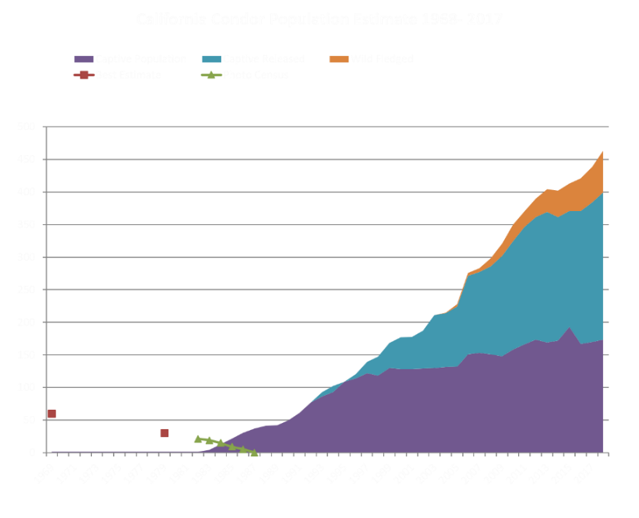
This population graph is more detailed than what the students will produce. They will only show one graph for the total population.

5. Sharing the Data
- After students have created their graphs in their expert group, instruct them to partner with one student from the other expert group to share their graphs
- Students should trade graphs and review them independently for 5 minutes and write down/draw what they notice and wonder.
- One at a time, students explain the graph they created, and try to answer their partner’s questions.

*Students should be able to explain that lead is the leading cause of death for condors (indirect negative impact) and that is why the population graph declines to zero. The conservation efforts of the FWS and California Condor Recovery Program (direct and indirect positive impact) are the reason for the growth of the population after reintroduction of the species in 1992.

Lesson 9 – Claim Evidence Reasoning
Unit Question: What role does the California condor play in the California ecosystem, and how do changes in the ecosystem impact condors over time?

Science and Engineering Practices:
- Engaging in argument from evidence
- Constructing explanations

1. Claim-Evidence- Reasoning
- Remind students of the question, “Could humans and condors have interactions in the environment?”
- Have students choose 2 claims:
    - Humans do interact with condors in the environment, or humans don’t interact with condors in the environment.
    - Humans have positive impacts on condors, or humans have negative impact on condors, or both.
- Using only the data from their graphs, show evidence for your claim in the table.
- In the table, describe the reasoning for why you chose the evidence.
“Claim you will defend goes here”
Evidence -  Scientific Facts:  Observations from graphs | Reasoning - explains how the evidence supports your claim.

Lesson Plan 10: The Condor’s Shadow & Do the Math!
Unit Question: What role does the California condor play in the California ecosystem, and how do changes in the ecosystem impact condors over time?

Science and Engineering Practices:
- Using Mathematics and Computational Thinking
- Analyzing and Interpreting Data

Teacher Prep: Have the Condor’s Shadow DVD or online video* ready to play. Day 2: Print/Share Do the Math! - worksheet and have calculators for students to use.
*password is: Pitahsi
Lesson: (two class periods)
- Intro
- Students will watch the documentary the Condor’s Shadow, and write down questions on post it notes to add to the “questions board”
  - Watch the video over 2 days, leaving 20 minutes for the activity day 2
Day 2
- Do the Math!
- Read through the worksheet with the students.
- Explain the equation we use to find out how many pounds of deer meat are in Ventura County
  - Some classes may need more assistance (walk through the problem’s equation with the correct values as a class) – use your discretion
- Students should work independently, but may need assistance from their peers.
  - Students will need calculators

*If students finish early, have them assist other students, revise their preliminary model, or generate questions for the guest speaker

Do the Math!
California condor: Nature’s Cleanup Crew!

Mule deer are a common sight in Ventura County’s wild spaces. They are an important part of a food web that includes vegetation like trees and shrubs, consumers like rabbits, and secondary consumers, or predators, like foxes, snakes, and mountain lions. Creatures like California condors, and ravens, as well as the many microscopic fungi, and bacteria make up the scavengers and decomposers in the food web.

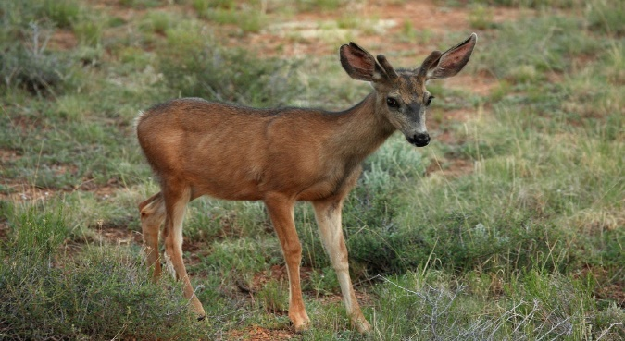

Important Facts:
- 170 lbs is the average weight of an adult mule deer.
- Carrying capacity is 40 deer per square mile (CDFW)
- Ventura County is 2208 square miles.

____lbs/deer x ____deer/mile² x ____mile² in Ventura County = _____lbs of deer meat in Ventura County

- How many pounds of mule deer exist in our county? _______________________

- If half of that population dies in any given year (hunting, natural causes), how many pounds of mule deer carcass would exist? ______________________

- If half of the carcass is taken/eaten by the primary predator (human, mountain lion, etc.), then how many pounds of carcass remains in the environment for scavengers (like California condors) and decomposers?
_____________________________________________

- If scavengers and decomposers did not exist, how could we dispose of carcasses throughout the environment?
_______________________________________________________________________________________________________________________________________________________________________________________________________________________________________________________________________________________________________________________________________________________________________________________

Lesson Plan 11: Question Formulation Technique
Unit Question: What role does the California condor play in the California ecosystem, and how do changes in the ecosystem impact condors over time?

Science and Engineering Practices:
- Asking Questions

Warm Up: Watch former Santa Barbara Zoo Nest Biologists Erin Arnold in action!

Lesson: (one class period)
- Intro
- Tell students they will have the chance to ask condor conservationists questions and will get written, video, or in class* responses.
*guest speaker is Park Ranger Daniel Cook from US Fish and Wildlife Service and he works at the Hopper Mountain National Wildlife Refuge Complex.

- Question Formulation Technique (QFT)
- In small groups or partners, have the students generate as many questions as they can that they would want to ask FWS Park Ranger Daniel Cook when he visits their class (5-10 mins).
    - Students can write their questions on post-it notes and put those questions on a piece of poster paper for each group.
- Next have the students label open ended questions with an “O” and close ended questions with a “C”
- Then have the students change one open ended question to a close ended questions. Then they will change one close ended question to an open-ended question.
- Have the students write their new questions on post-its and have them put these questions on the poster paper.
- Have student groups pick their top 3 questions. Have each group share out their top 3 questions. Add these questions to your Question Board.

Lesson Plan 12: Microtrash Madness!!!
Unit Question: What role does the California condor play in the California ecosystem, and how do changes in the ecosystem impact condors over time?

Science and Engineering Practices:
- Developing and Using Models
- Obtaining, Evaluating, and Communicating Information

Teacher Prep: Coordinate with FWS Park Ranger for in class, or video visit. If Park Ranger cannot come to class with game, coordinate and prepare materials for Microtrash Game:
- 1 tub/ bucket
- Cover for tub with 1 – 4 slots
- Lots of shell, bone, and microtrash (pieces: 25, 15, 30)

Lesson: (one - two class periods)
  - Warm Up: Condor chick nest cam clips
Have students write what they wonder on post it notes for the question board

  - Intro (10-20minutes)
- Questions prepared during previous lesson, top 5 selected
- Q & A with Park Ranger

“You have learned a lot about California condors. You know about their role in the environment, and how they can be impacted by other species, including humans, and how they benefit and impact the environment, and us people, as well. Lead plays a big role in that relationship. California condor chicks have another threat to be concerned about. Microtrash. Small bits of glass, metal, and plastic that condors confuse for bone and shell they feed their fast growing chicks. They find the bone using their sense of touch, not sight. Let’s see what it’s like to be a condor parent, searching for calcium in bones and shells for you newly hatched chick.”

- Microtrash Game (25 minutes)
- In groups of 4, have students sit around a prepared and covered game tub
- Explain the goal of the game (raise a condor chick to fledgling)
- Pass out and explain the instructions and Impact Cards
- Let the students play!

- Final Revisions to the Preliminary Model
- Add in final revisions, and chick/nesting information
- Recreate the Preliminary Model on a blank worksheet
  - Preliminary models, revisions, and final should all be kept

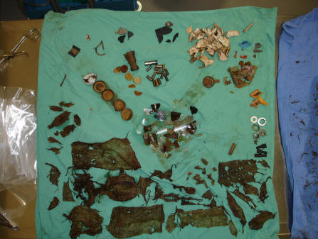
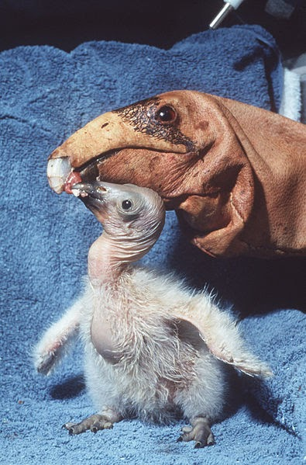
Microtrash Madness
Your job is to collect bits of shell and bone for your chick.
Be careful not to choose microtrash!!!
If you fledge, you’re a winner!

DIRECTIONS:
- Take turns choosing 3 objects from the tub. Condors use their sense of touch, not sight, to find the correct materials for their chicks to eat.
- After “feeding your chick”, draw one Impact Card, and follow the directions. Adjust your score as directed. Now it is the next players turn.
- Record how many pieces of microtrash you select. Record how many pieces of bone or shell you select. Return bone and shell after each round. Keep microtrash – chicks can’t digest it, so it stays in their stomachs.
- If you collect 5 pieces of microtrash, your condor chick dies - sorry, you are out of the game. All chicks that make it through 6 rounds go on to fledge – learn to fly

Lesson Plan 13: Public Service Announcement: Save the Birds
Unit Question: What role does the California condor play in the California ecosystem, and how do changes in the ecosystem impact condors over time?

Science and Engineering Practices:
- Asking Questions

Lesson: (one class period)
- Intro
- What does the California condor need to thrive again – to be taken off the endangered species list? Think about changes in human behavior…
  - YOU can help!

- Elaborate: Save the Birds
  - Students will choose a project: design a product/app, create a PSA, scientific poster, art piece, develop a technique for field biologists or Zoo staff, etc…
    - Video, poster, signs, billboard, story map, skit, song, etc...
    - GPS unit design, citizen science project, drones for nest entries, etc…
    - Funny video example - Serious video example - Kid made signs

- Teacher’s share top projects with SB Zoo and/or FWS Park Ranger
  - Possibility to share student PSAs on Facebook or websites

Lesson 14: Evaluation – Claims, Evidence, and Reasoning
Unit Question: What role does the California condor play in the California ecosystem, and how do changes in the ecosystem impact condors over time?

Science and Engineering Practices:
- Constructing Explanations
- Engaging in Argument from Evidence

Lesson: (one class period)
- Students will write a claim-evidence-reasoning answering the unit question: What role does the California condor play in the California ecosystem, and how do changes in the ecosystem impact condors over time?

- Students will use evidence from their model, the article, the video, the microtrash game, their data sheets, and other activities to support their claim.

“Claim you will defend goes here”
Evidence -  Scientific Facts from GIS data, models, graphs, articles | Reasoning - explains how the evidence supports your claim.

Stewardship: Monitoring a California condor with GPS
Studbook ID: ________ Sex: F __ M󠅾 __ Hatch Date: ___________ Age: ___
Expand the data folders and turn on one day’s data at a time. Follow these steps for each day’s data:
- Adjust the time scale sliders: record First Flight time and Roost Start time.
(Roost Start time – First Flight time) = Time Active
- Follow the flight path of the condor to find Perch Sites: data point < 6m above ground.
- Use the “Flight Path” data to determine Flight Miles.
- Use the polygon tool to measure the area of the range being used for the week:
Area: __________miles² (Area ÷ Total Range) x 100 = Percent: __________
*Total Range = 18,000mi²
Week 1
Date | First Flight Time | Roost Start Time | Time Active | Perch Sites | Flight Miles | Area Used  (miles²)
AVERAGE:
Week 2
Date | First Flight Time | Roost Start Time | Time Active | Perch Sites | Flight Miles | Area Used  (miles²)
AVERAGE:
Week 3
Date | First Flight Time | Roost Start Time | Time Active | Perch Sites | Flight Miles | Area Used  (miles²)
AVERAGE:
Average = (day 1 data + day 2 data + day 3 data + …) ÷ number of days’ data
Weekly are used = area on map of all week’s data, not adding together daily area used

Date | First Flight Time | Roost Start Time | Time Active | Perch Sites | Flight Miles | Area Used  (Miles²)
AVERAGE:
One of Many: Looking at individuals in a flock
Week 4
- Record the data with the rest of the class in the teacher’s database
- Record the average for the flock each week, then find their actual averages over time.
Population Data: Putting it all together
 | Avg Start Activity Time | Avg End Activity Time | Avg Time Active | Avg # Perch Sites | Avg Flight Miles | Avg Area Used/day (Miles²) | Avg Area Used/week (Miles²)
Week 1 Flock Averages:
Week 2 Flock Averages:
Week 3 Flock Averages:
Week 4 Flock Averages:
Flock Avg:

- View all of your condor’s daily use area of the range shape files at the same time. Draw a new shape file surrounding all of your condor’s daily area shapes to find the weekly area used. Use the same technique adding together the weekly areas to find your total over time.

Total flock area of the range used: ________________miles²
Total percentage of the range used: __________%

